TIME PROBLEMS
KS1 – 2003 Paper 2
1.
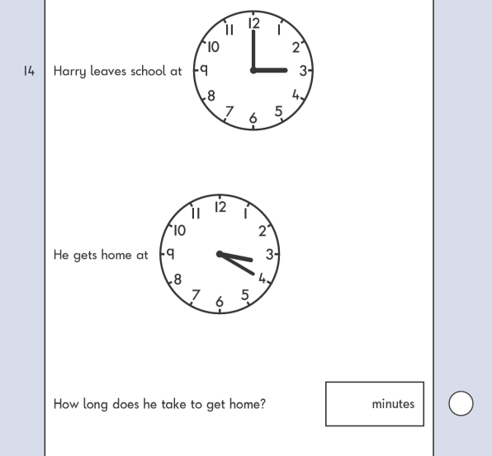
KS1 – 2004 Paper 2
2.

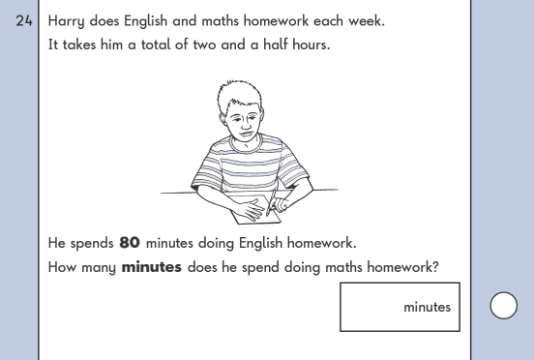
KS1 – 2017 Paper – Reasoning
3.

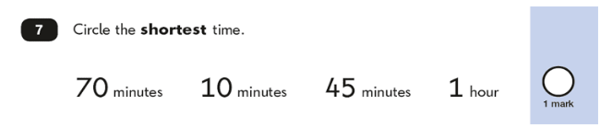
KS1 – 2018 Paper – Reasoning
4.

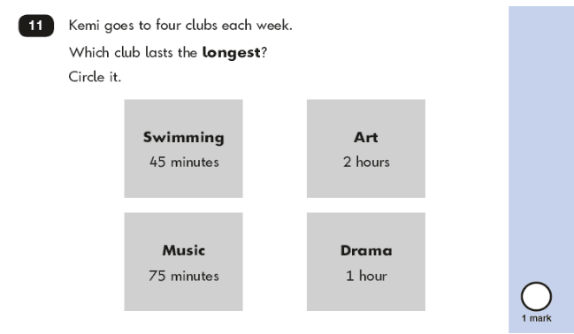
5.
